Endpoints

🔹 What Are Endpoints?
# Source: Chatgpt (GPT-5-Mini) at [1/16/2026]
In the context of APIs (especially REST APIs), an endpoint is a specific URL (or URI) where a client can access a resource or perform an action on the server.

✅ Key Points About Endpoints:
# Source: Chatgpt (GPT-5-Mini) at [1/16/2026]
- An endpoint is the address where the API listens for requests.
- It represents a specific function or resource in the API.
- Each endpoint corresponds to a unique URL path combined with an HTTP method (GET, POST, etc.).
- Endpoints are like entry points into the API’s services.

🔍 Example:
# Source: Chatgpt (GPT-5-Mini) at [1/16/2026]
For a REST API managing users, common endpoints might be:
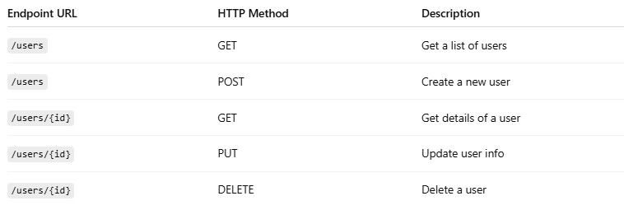
Endpoint URL | HTTP Method | Description
/users | GET | Get a list of users
/users | POST | Create a new user
/users/{id} | GET | Get details of a user
/users/{id} | PUT | Update user info
/users/{id} | DELETE | Delete a user

🧠 Example in Full URL:
# Source: Chatgpt (GPT-5-Mini) at [1/16/2026]
https://api.example.com/users/42

- This is an endpoint that might get or update user with ID 42, depending on the HTTP method used.

✅ Summary:
# Source: Chatgpt (GPT-5-Mini) at [1/16/2026]
An endpoint is the URL + method combination that lets you interact with a particular resource or function on a REST API.

